TRYHACKME LAB REPORT

Windows Fundamentals 1
Internship: DG Interns HUB — Week 2
Platform: TryHackMe
Room: Windows Fundamentals 1
Domain: Windows Operating System and Cybersecurity
Tool: Windows VM
1. Aim
To understand the basic components of the Windows operating system, including the file system, user accounts, User Account Control (UAC), and built-in administrative tools.

2. Objectives
- Understand the Windows desktop and user interface.
- Learn about Windows file systems and file permissions.
- Understand user accounts and account privileges.
- Learn the purpose of User Account Control.
- Explore Control Panel and system settings.
- Understand the importance of Windows security features.

3. Introduction
Windows is an operating system used on personal computers and in business environments. Understanding its components is important for cybersecurity professionals because many security investigations involve Windows endpoints.
Windows provides tools for managing files, configuring system settings, controlling user privileges and protecting the system from unauthorized changes.

4. Important Concepts

4.1 Windows File System
A file system organizes files and folders on a storage device.
NTFS (New Technology File System) is a common Windows file system. It supports file permissions, metadata, auditing capabilities and other features.
Key points:
- Organizes files and directories.
- Supports access control permissions.
- Stores information about files and folders.
- Helps control which users can access resources.

4.2 User Accounts
A Windows user account represents an identity used to sign in and access system resources.
Common account types:
- Standard user: Has limited permissions for everyday tasks.
- Administrator: Can perform administrative tasks when appropriately elevated.
- Guest or restricted account: May provide limited access, depending on configuration.
The principle of least privilege means giving users only the permissions they need.

4.3 User Account Control (UAC)
UAC is a Windows security feature that helps prevent unauthorized changes to the operating system.
Key points:
- May request consent or administrator credentials.
- Helps control elevated operations.
- Reduces the risk of accidental system changes.
- Does not replace antivirus software or other security controls.

4.4 Control Panel and Settings
Control Panel and Windows Settings provide interfaces for managing system configuration.
Examples include:
- User accounts.
- Installed applications.
- Devices and printers.
- Network configuration.
- System and security settings.

4.5 Windows Security
Windows Security provides access to security features such as antivirus protection, firewall settings and device security information.
Security analysts use these features to understand the system's protection status.

5. Practical Methodology
- Sign in to TryHackMe.
- Open the Windows Fundamentals 1 room.
- Start the required lab environment, if requested.
- Follow the room instructions in sequence.
- Explore the Windows features covered in each task.
- Record the answers based on actual observations.
- Capture screenshots of important steps and completed tasks.

6. Results and Findings
Complete this section after performing the lab.
Item | Actual Observation
Windows version | [Enter observed version]
File system concept | [Enter your observation]
User account feature | [Enter what you learned]
UAC purpose | [Explain in your own words]
Windows security feature | [Enter the feature examined]

7. Security Relevance
Understanding Windows accounts, permissions and security settings helps analysts investigate unauthorized access, privilege misuse and insecure configurations.
For example, an unexpected change to user privileges may require checking account-management events and confirming whether the change was authorized.

8. Challenges and Limitations
- Windows interfaces may differ between versions.
- Available settings depend on account privileges.
- Some features may require administrator approval.
- Findings should be based on the actual lab environment.

9. Learning Outcomes
- Understand basic Windows components.
- Explain the purpose of NTFS.
- Distinguish standard and administrator accounts.
- Explain the role of UAC.
- Identify Windows security and configuration tools.
- Document lab findings professionally.

10. Evidence Checklist
- Screenshot of the TryHackMe room.
- Screenshots of relevant Windows tools.
- Completed room tasks and answers.
- Actual observations recorded in the findings table.
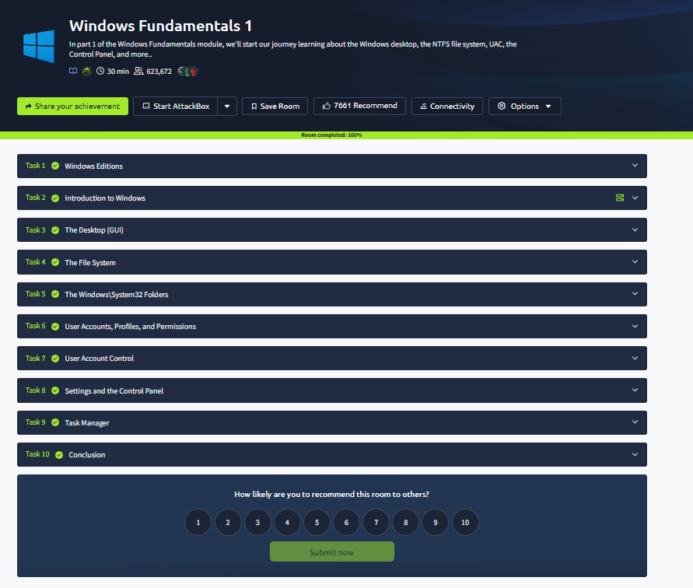

11. Conclusion
The Windows Fundamentals 1 lab introduces essential Windows components, file system concepts, user accounts and security controls. This knowledge provides a foundation for investigating Windows security events and suspicious endpoint activity.

